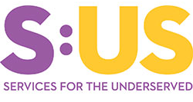
Supportive Services For
Veteran Families
Providing assistance to Veterans who are homeless or at
risk of becoming homeless in Nassau and Suffolk Counties

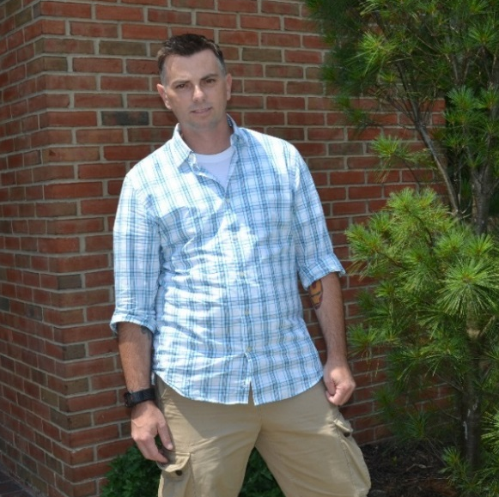  “SUS brought me back to life. I had nothing to look forward to. I woke up every morning miserable, wondering how I was going to scrape together enough money to buy food and maintain my car. SUS assisted me in getting my life back on track.”  — Kevin T.  BASIC ELIGIBILITY  Who qualifies and who does not?  The Supportive Services for Veteran Families (SSVF) program provides assistance to Veterans who are homeless or at risk of becoming homeless. Veterans must be in a housing crisis to qualify for the SSVF program.  Veterans with active duty service from all eras who were discharged with any status other than Dishonorable, may qualify for SSVF.  NASSAU-SUFFOLK, NY HUD METRO FMR AREA  2022 Median Income: $146,400  Very Low (50%) Income Limit Extremely Low (30%) Income Limit  PERSONS IN FAMILIY 1 $50,900 $30,500  2 $58,150 $34,900  3 $65,400 $39,250  4 $72,650 $43,600  5 $78,500 $47,100  6 $84,300 $50,600  7 $90,100 $54,100  8 $95,900 $57,600  Current and former members of the Reserves and National Guard who were called up to active duty by Federal Order (training does not count), would qualify for SSVF services. SSVF will also work to refer individuals who do not qualify for the program to other organizations that may be able to assist.  HUD VASH and Grant and Per Diem Program participants are eligible for SSVF services if they have extremely low income, 30% of the AMI. See chart above.  Veteran’s income must be at or below 50% of the Area Median Income (AMI) in order to be eligible for SSVF. See chart above. | REQUIRED GEAR  What to bring to your appointment…  Upon initial screening, a few documents are needed to verify Veteran status and eligibility. Please have the following documents ready for your intake meeting. (If you need assistance obtaining these documents please let us know)  - DD214. If you cannot provide your DD214 at the time of intake a VA Card, HINQ, or Letter of Service may serve as proof of Veteran status.  - Birth Certificate, Social Security card and state ID for all members of the household.  - Two most recent pay stubs for all employed members of the household.  - Award letters for SSI, SSD, SSA, DSS benefits, VA Service connection, VA non-service connected pension for all members of the household.  - Two most recent bank statements for all household members showing any additional income including: retirement pension, child support, alimony payments and/or Unemployment Insurance benefits.  - Utility shut off notice(s).  - Eviction notice.  - Letter of shelter stay from shelter Case Manager.  - Discharge paper from hospital or institution.  SSVF grant funds may not be used to pay any of the following items:  - Mortgage costs  - Construction costs  - Credit cards for consumer debt  - Car payments  - Pet care  - Court-ordered fees/fines  For more information and an expanded list, contact program staff.  CONTACT US  Learn more about the SSVF program at:  John Dillon (646) 357-0928  Maria Caccavale (646) 689-6934  600 Albany Ave, Suite 1, Amityville, NY 11701  Tel: (631) 227-0777 l Fax: (855) 232-8285  www.sus.org  @sus_org  ServicesfortheUnderServed
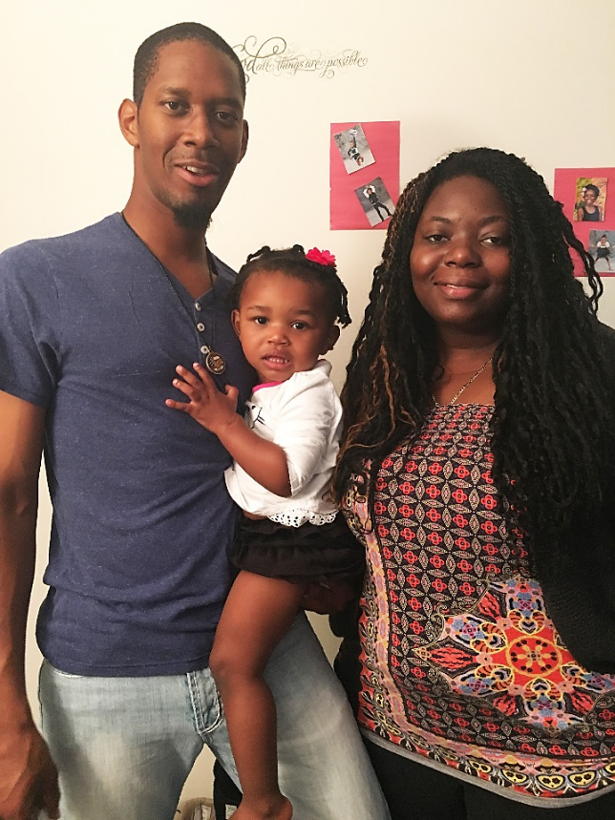
WHAT SERVICES DOES SSVF PROVIDE?
“It was a sense of relief and overwhelming happiness after all of the things that we had to go through, we finally got to move somewhere we could live instead of a shelter. This definitely put the icing on the experience that our family needed to function at a normal level.”
—Daeshawn M.

SSVF provides two basic type of
services: Wrap-Around Services and Temporary Financial Assistance (TFA).

Wrap-Around Services include but are not limited to:
- Emergency Housing Referrals
- Housing Search Assistance
- Connection to Local, State and Federal Benefits
- Employment Support
- Financial Literacy Education
- Budget Consultation
- Transportation Assistance
- Food Pantry
- Access to clothing, household items and hygiene products

In addition to the above services, SSVF may be able to provide Temporary Financial Assistance (TFA) to those who qualify.

TFA services are provided on a
case-by-case basis and may include:
- Rental Assistance
- Rental Arrears
- Security Deposit
- Broker Fee
- Storage Fees
- Storage Arrears
- Moving Costs
- Utility Arrears
- General Housing Stability
- Emergency Housing
- Child Care

HOW CAN SSVF HELP?
It’s not just about housing…
The goal of Supportive Services for Veteran Families (SSVF) is to assist Veterans achieve self-sufficiency, long-term housing stability and an improved quality of life. SSVF is able to provide an array of support services to assist Veterans by addressing the root causes of homelessness.
SSVF can help Veterans achieve sustainability and success through the following:
Outreach: The Outreach team builds and maintains relationships throughout the community by attending VA and non-VA sponsored events, and targets low-income Veteran families who may be in need of assistance.
Housing: Following Housing First principles, the SSVF housing team can provide assistance in searching for room, apartment and house rentals that fall within the Veterans budget. The team will also negotiate rent and lease terms with landlords, educate participants on lease agreements and assist in building landlord tenant relationships.
Service Coordination: Service Coordinators provide specialized one-on-one case management by coordinating linkages to support services. They work closely with the Veteran or Veteran’s family to create individual Housing Stability Plans in order to work toward and achieve sustainability.
Benefit Services: Benefit assistance can be obtained for Veterans through agencies such as DSS (SNAP & Medicaid), Social Security Administration (SSI/SSD), and Veterans Benefit Administration (service connection/non-service connection).
Employment: The employment team is committed to locating employment opportunities for Veterans that best match their skills and experience. Assistance can include creating/updating resumes, working on interview skills and job searches.
.

CONTACT US
John Dillon (646) 357-0928
Maria Caccavale (646) 689-6934
600 Albany Ave, Suite 1, Amityville, NY 11701
Tel: (631) 227-0777 l Fax: (855) 232-8285
www.sus.org
Learn more about the SSVF program at:
ServicesfortheUnderServed

@sus_org

